**Week 6 (22 Aug 2022 to 28 Aug 2022)**

**Unit 3.2 (Logic Gates) Homework**

1a) Identify the name and draw a single logic gate that can replace the one show below

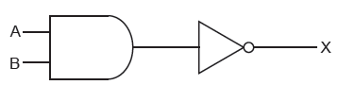

**Name of Gate**: **Drawing of Gate:**

1b) Identify the name and draw a single logic gate that can replace the one show below

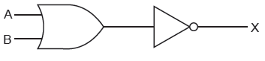

**Name of Gate**: **Drawing of Gate**:

2) Complete the truth table for this logic circuit

[8 marks]

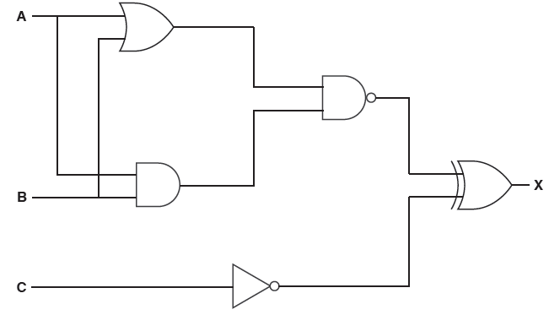

|  |  |  |  |  |
| --- | --- | --- | --- | --- |
| **A** | **B** | **C** | **Working Space** | **X** |
| 0 | 0 | 0 |  |  |
| 0 | 0 | 1 |  |  |
| 0 | 1 | 0 |  |  |
| 0 | 1 | 1 |  |  |
| 1 | 0 | 0 |  |  |
| 1 | 0 | 1 |  |  |
| 1 | 1 | 0 |  |  |
| 1 | 1 | 1 |  |  |